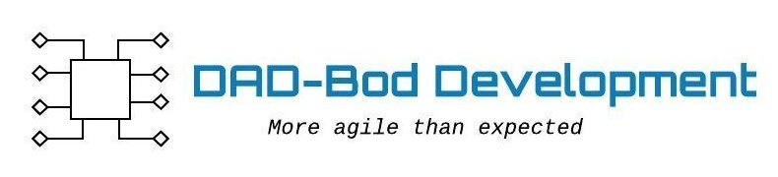

**Vision Statement**

FOR people that like to play tabletop gamesWHO want to be able to find others with similar interests THE Tabletop Event App (working title)IS a web-based application THAT lets tabletop gamers set up events as well as find events that others have posted publicly. UNLIKE similar sitesOUR PRODUCT is specialized toward tabletops and ensuring the safety of our users while helping the tabletop gaming community to grow.